**CREATE DESIGN UNDER TEST IN VERILOG, TESTBENCH ENVIRONMENT FOR I2C PROTOCOL WITH ASSERTION AND A PERL SCRIPT FOR I2C BUS LOG ANALYZER**

A thesis submitted in partial fulfillment of the requirements for the award of the degree of

**B. Tech**

**in**

**Electronics and Communication Engineering**

By

**PRANES S (108121091)**



**ELECTRONICS AND COMMUNICATION ENGINEERING**

**NATIONAL INSTITUTEOF TECHNOLOGY**

**TIRUCHIRAPALLI-620015**

**MAY 2024**

**CREATE A DESIGN UNDER TEST IN VERILOG, TESTBENCH ENVIRONMENT FOR I2C PROTOCOL WITH ASSERTION AND A PERL SCRIPT FOR I2C BUS LOG ANALYZER**

A thesis submitted in partial fulfillment of the requirements for the award of the degree of

**B. Tech**

**in**

**Electronics and Communication Engineering**

By

**PRANES S (108121091)**



**ELECTRONICS AND COMMUNICATION ENGINEERING**

**NATIONAL INSTITUTEOF TECHNOLOGY**

**TIRUCHIRAPALLI-620015**

**MAY 2024**

**BONAFIDE CERTIFICATE**

This is to certify that the project titled ‘**Create** **Design under test in Verilog, create a testbench environment for I2C protocol with assertion and a Perl script for I2C bus log analyzer**’ is a bonafide record of the work done by

**Pranes (108121091)**

in partial fulfillment of the requirements for the award of the degree of **Bachelor of Technology** in **Electronics and Communication Engineering** of the **NATIONAL INSTITUTE OF TECHNOLOGY, TIRUCHIRAPPALLI,** during the year 2024-2025.

**Dr. M.Bhaskar**

Head of the Department

**Dr. Srinivasulu Jogi**

Guide

Project Viva-voce held on ________________________________

**Internal Examiner** **External Examiner**

**ABSTRACT**

In modern digital systems, verifying communication protocols like I2C (Inter-Integrated Circuit) is essential for ensuring robust and reliable data exchange between integrated components. This project focuses on developing a Design Under Test (DUT) for an I2C-based communication system using Verilog, and constructing a self-checking testbench environment that includes assertions and a Perl-based I2C bus log analyser. Additionally, the potential intersection with SERDES (Serializer/Deserializer) in high-speed data environments is briefly explored to highlight broader applications.

The DUT comprises two key modules: an I2C Master and an I2C Slave, implemented in Verilog. The Master module initiates communication, controls clock generation, and handles read/write operations based on input stimuli, while the Slave responds accordingly based on addressing and control signals. To simulate real-world bus behaviour, open-drain characteristics of I2C are modelled using pullup primitives on the shared SDA and SCL lines.

The testbench is developed using System Verilog and incorporates UVM-inspired verification principles. It includes interfaces, randomized stimulus generation, scoreboard comparison, and synchronizing logic. A key aspect of the environment is the integration of System Verilog assertions to enforce protocol correctness, such as START and STOP condition checks, SDA/SCL toggling, and acknowledgment behaviour.

For post-simulation analysis, a Perl script is written to parse simulation logs and extract I2C transactions. The script identifies start/stop conditions, byte-level data transfer, ACK/NACK signalling, and highlights protocol violations. This enhances debug efficiency and acts as a lightweight transaction-level monitor without GUI-based tools.

Though I2C is inherently low-speed, the discussion extends into how SERDES blocks, typically used in high-speed serial links, can be involved. In advanced SoCs, SERDES can carry I2C-like control signals in embedded management channels or configuration buses, especially when aggregating multiple protocol streams onto high-speed serial links. Integrating protocol verification, assertion-based checking, and log analysis in such mixed-speed environments becomes crucial.

This work demonstrates a comprehensive and scalable approach to I2C protocol verification using Verilog, System Verilog assertions, and Perl scripting. It showcases how verification environments can be extended beyond simulation to include assertion-based checks and automated log analysis, while also being adaptable for integration with SERDES-based interconnects in complex chip architectures.

*Keywords:* SERDES, I2C, UVM, PERL

**TABLE OF CONTENTS**

**Title** Page No.

**ABSTRACT** ........................................................................................................... 3

**ACKNOWLEDGEMENTS** ................................................................................... ii

**TABLE** **OF CONTENTS** ....................................................................................... 5

**LIST OF FIGURES**............................................................................................... vi

**CHAPTER 1 INTRODUCTION………………………………………………..**

1.1 General Motivation ……………………………………………………….. 1

1.2 My Contribution ………………………………………………………….. 2

**CHAPTER 2 LITERATURE REVIEW ………………………………………..**

2.1 Related works …………………………………………………………………. 3

2.2.1 A Mini I²C Bus Interface Circuit Design and Its VLSI ……………...

Implementation

2.2.2 Design and Implementation of I²C Master Controller for Serial …….

Communication Using VHDL

2.2.3 Design and Verification of I²C Protocol Using DUC and DDC………

2.2.4 Design and Simulation of I²C Protocol ………………………………

2.2.5 Design and Implementation of Built-In Self-Test (BIST) ……………

Master-Slave Communication Using I²C Protocol

2.2.6 Design of I²C Protocol in Verilog - A New Approach ………………..

**CHAPTER 3 METHODOLOGY…………………………………………………**

3.1Master_Module

3.1.1 State Machine Design …………………………………………………

3.1.2 Start and Address Phases ……………………………………………...

3.1.3 Acknowledge Phase …………………………………………………..

3.1.4 Write Operation ………………………………………………………

3.1.5 Read Operation ………………………………………………………

3.1.6 Stop Condition ………………………………………………………

3.1.7 Open-Drain Handling for SDA and SCL ……………………………

3.2 Slave_Module

3.2.1 Start Detection and State Machine Initialization ……………………

3.2.2 Address Recognition ………………………………………………...

3.2.3 Read/Write Data Phase ……………………………………………...

3.2.4 Data Acknowledgment and Latching ………………………………..

3.2.5 Stop Condition and Recovery………………………………………..

3.2.6 Open-Drain Output Handling………………………………………...

3.3 Verification Environment

3.3.1 packet (transaction) …………………………………………………..

3.3.2 Generator ……………………………………………………………..

3.3.3 Driver………………………………………………………………….

3.3.4 Interface………………………………………………………………..

3.3.5 Monitor………………………………………………………………...

3.3.6 Scoreboard……………………………………………………………..

3.3.7 Testcase………………………………………………………………...

3.3.8 Assertion………………………………………………………………..

3.4 I2C Format

3.4.1 Start Condition………………………………………………………….

3.4.2 Address Phase…………………………………………………………..

3.4.3 Acknowledgment (ACK/NACK) ………………………………………

3.4.4 Data Transfer……………………………………………………………

3.4.5 Repeated Start Condition……………………………………………….

3.4.6 Stop Condition………………………………………………………….

3.4.7 Arbitration and Clock Stretching………………………………………

**CHAPTER 4 SIMULATION RESULTS………………………………………….**

4.1 EDA Playground simulation output …………………………………………….

4.1.1 Master’s Simulation Results…………………………………………..

4.1.2 Slave’s Simulation Results ……………………………………………

4.2 Data Comparison simulation output…………………………………………….

4.3 Assertion output…………………………………………………………………

4.4 Perl script output………………………………………………………………...

**CHAPTER 5 CODE COVERAGE……………………………………………….**

5.1 Work Done in Code Coverage…………………………………………………..

5.1.1 Line (Statement) Coverage……………………………………………

5.1.2 Toggle Coverage………………………………………………………

5.1.3 Condition Coverage……………………………………………………

5.1.4 Branch Coverage………………………………………………………

5.1.5 FSM (Finite State Machine) Coverage……………………………..…

5.1.6 Expression Coverage………………………………………………….

5.2 Code coverage flow……………………………………………………………..

5.2.1 Coverage Database Generation ………………………………………

5.2.2 Simulation Setup………………………………………………………

5.2.3 Simulation and Coverage Collection………………………………..…

5.2.4 Integration with Verification Planning Tools…………………………..

**CHAPTER 6 SUMMARY AND CONCLUSION………………………………...**

6.1 Summary…………………………………………………………………………

6.2 Conclusion……………………………………………………………………….

6.3 Future Work ……………………………………………………………………..

**REFERENCES** …………………………………………………………………….

**LIST OF FIGURES**

|  |  |  |
| --- | --- | --- |
| **Figure No.** | **Title** | **Page no.** |
| *Fig. 3.1* | Overall Schematic of I2C Master |  |
| *Fig. 3.2* | I2C Master’s Input side |  |
| *Fig. 3.3* | I2C Master’s Output side |  |
| *Fig. 3.4* | Overall Schematic of I2C Slave |  |
| *Fig. 3.5* | I2C Slave’s Input side |  |
| *Fig. 3.6* | I2C Slave’s Output side |  |
| *Fig. 3.7* | Testbench Architecture |  |
| *Fig. 3.8* | Format of I2C Protocol |  |
| *Fig.4.1* | Waveform showing the correct working of I2C Master |  |
| *Fig.4.2* | Waveform showing the correct working of I2C Slave |  |
| *Fig.4.3* | Handshake between I2C Master and Slave |  |
| *Fig.4.4* | Data Comparison Simulation output |  |
| *Fig.4.5* | Assertion START condition result |  |
| *Fig.4.6* | Assertion STOP condition result |  |
| *Fig.4.7* | Bus Log for one data and address in simulation time |  |
| *Fig.4.8* | I2C Bus log |  |
| *Fig.4.9* | Perl Script Output |  |
| Fig.5.1 | Line Coverage in Verdi Tool |  |
| Fig.5.2 | Code Coverage in Verdi tool |  |

**CHAPTER 1**

**INTRODUCTION**

**1.1 General Motivation**

I²C (Inter-Integrated Circuit) is a widely used synchronous, multi-master, multi-slave, two-wire serial communication protocol. Developed by Philips (now NXP), I²C facilitates efficient short-distance communication between components like microcontrollers, EEPROMs, sensors, and peripherals on a single PCB. It operates using just two signals: SDA (Serial Data Line) and SCL (Serial Clock Line), making it ideal for low-complexity interconnects.

In the field of VLSI verification engineering, I²C protocol plays a significant role during the design verification of SoCs and IPs that integrate embedded communication blocks. I²C controllers often serve as configuration or control interfaces for peripheral IPs such as ADCs, temperature sensors, or PMICs within a chip. As a verification engineer, it becomes crucial to validate both functional correctness and protocol compliance of these I²C components.

To ensure this, System Verilog testbenches are created that mimic real-world I²C master or slave devices, generate random transactions, monitor response behaviour, and flag protocol violations. The use of System Verilog assertions (SVA) enhances the reliability of this process by checking for conditions like valid START and STOP sequences, correct clock-to-data relationships, and proper acknowledgment handling. These assertions help catch corner-case bugs early in simulation.

To complement simulation-based checks, Perl scripting is often used in the verification workflow for post-processing simulation logs. Perl is well-suited for parsing large log files, identifying transaction boundaries, extracting payloads, flagging anomalies, and generating summarized reports. For instance, a Perl script can automatically analyse a waveform log to find whether a STOP condition occurred after every complete data transaction or if NACK was sent after an incorrect address. This allows verification engineers to automate validation and debugging without manually inspecting waveforms.

Furthermore, in advanced chip designs, I²C signals might be routed over SERDES (Serializer/Deserializer) lanes in compact, high-speed environments. This makes protocol verification more complex, as control signals may be serialized along with other traffic. Nevertheless, fundamental I²C compliance must still be ensured, and the verification principles remain applicable even in these high-speed.

**1.2 My Contributions**

* To learn about System Verilog, UVM (Universal Verification Methodology), Perl scripting language
* Write Verilog Code for master and slave of I2C and testbench code in System Verilog
* Create a Perl script for I2C bus log analyzer
* Code Coverage for a proc in Synopsys

**LITERATURE REVIEW**

**2.1 RELATED WORKS**

**2.1.1 A Mini I²C Bus Interface Circuit Design and Its VLSI Implementation**

Published in *The Journal of Supercomputing*, this paper introduces a compact I²C interface supporting both master and slave modes with minimal CPU intervention. The design employs independent finite state machines (FSMs) for each mode, resulting in a 50% reduction in CPU instructions during data transmission compared to existing solutions. Synthesized using Huahong 95 nm CMOS technology, the implementation occupies only 14% of the area and consumes 3.6% of the power relative to an open-source I²C design, making it suitable for low-power systems.

**2.2.2 Design and Implementation of I²C Master Controller for Serial Communication Using VHDL**

This study focuses on developing an I²C master controller using VHDL for FPGA applications. The design utilizes a simple two-wire interface (SDA and SCL) to facilitate efficient serial communication. The controller's functionality was validated by interfacing with a DS1307 real-time clock (RTC) module, demonstrating reliable data transmission and reception.

**2.2.3 Design and Verification of I²C Protocol Using DUC and DDC** ​

This paper explores the integration of I²C protocol with Digital Up Converter (DUC) and Digital Down Converter (DDC) systems. The authors designed the DUC and DDC modules in MATLAB and employed I²C for communication between them. This approach highlights the protocol's versatility in facilitating data transfer between digital signal processing components.

**2**.**2.4** **Design and Simulation of I²C Protocol**

This research presents the design and simulation of an I²C serial interface using Verilog HDL. Simulated on ModelSim 6.4a, the study emphasizes the protocol's efficiency in enabling communication between devices with varying speeds without data loss. The implementation underscores I²C's simplicity and effectiveness in serial data transmission.

**2.2.5** **Design and Implementation of Built-In Self-Test (BIST) Master-Slave Communication Using I²C Protocol**

This paper discusses incorporating a Built-In Self-Test (BIST) mechanism into I²C master-slave communication systems. The BIST approach enhances the reliability and testability of I²C interfaces, ensuring robust performance in integrated circuits. The implementation demonstrates the feasibility of integrating self-testing capabilities within standard communication protocols.

**2.2.6 Design of I²C Protocol in Verilog - A New Approach**

This study proposes a novel method for designing the I²C protocol using Verilog HDL. The authors compare I²C with other serial communication protocols like SPI and CAN, highlighting I²C's advantages in terms of simplicity and efficiency. The paper provides insights into implementing I²C in hardware description languages for various applications.

**3. METHODOLOGY**

**3.1Master_Module**This Verilog module models an I²C master controller that communicates with an I²C slave using standard protocol sequences. It includes inputs such as clock (clk), read/write control (rd_wr), start and stop control, a reset signal, a 7-bit slave address, and 8-bit input data. The outputs include an 8-bit data output (dout) and open-drain lines for the I²C clock (SCL) and data (SDA). The master controls both SCL and SDA lines to initiate communication, transmit the slave address, read or write data, and properly terminate the session. The bidirectional nature of SDA is handled using conditional assignments to support reading acknowledgments and data from the slave.

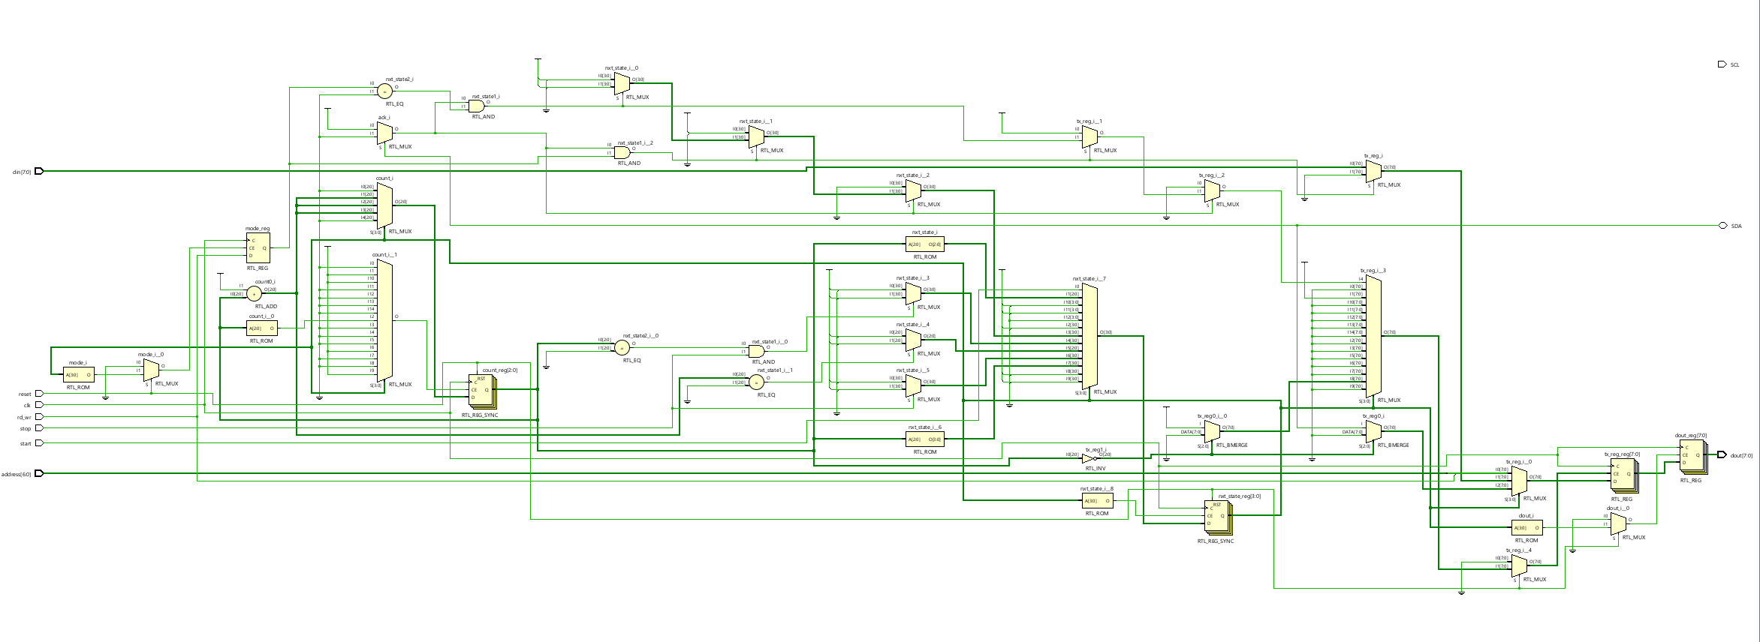

*Fig. 3.1. Overall Schematic of I2C Master*

**3.1.1 State Machine Design**

The I²C master logic is governed by a finite state machine (FSM) with 15 defined states, from S0 (idle) to S14 (stop). These states manage the sequential flow of the protocol. The FSM begins in the idle state and waits for a high signal on the start input. When this occurs, the FSM transitions through states to generate the start condition, transmit the address and R/W bit, check for acknowledgment, transfer or receive data, and finally generate the stop condition. This clear state separation makes the design structured and easier to manage for both write and read transactions.

**3.1.2 Start and Address Phases**

The communication begins in state S0 when the master is idle. Upon receiving a high start signal, the FSM moves to S1, where it pulls SDA low while SCL remains high to create a valid I²C start condition. Then, in S1 to S3, the master serially transmits the 7-bit address concatenated with the R/W bit through the SDA line. This is done by shifting out bits from a transmission register (tx_reg) and toggling the SCL line appropriately to latch the bits.

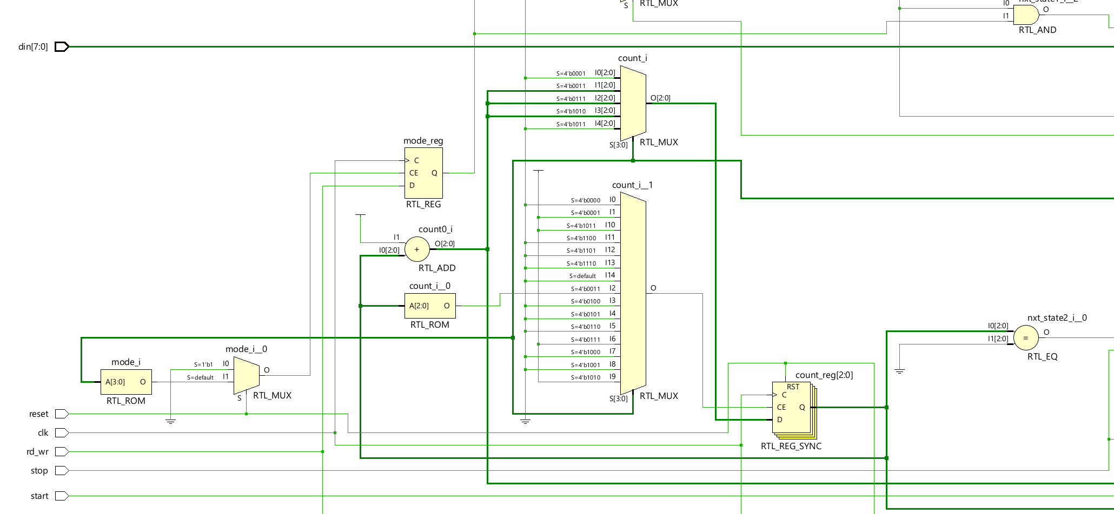

*Fig. 3.2. I2C Master’s Input side*

**3.1.3 Acknowledge Phase**

Once the address and R/W bit are transmitted, the FSM moves into the acknowledgment phase (S4 and S5). The master releases the SDA line and waits for the slave to pull it low, indicating an ACK. If the slave sends a NACK (SDA remains high), the master resets to the idle state. If ACK is received, the FSM proceeds to either the transmit (write) or receive (read) phase based on the value of the rd_wr signal.

**3.1.4 Write Operation**

In write mode (rd_wr = 0), the FSM enters states S6 and S7, where the 8-bit data from the din input is loaded into tx_reg and sent to the slave, bit by bit, on the SDA line. As each bit is placed on SDA during the falling edge of SCL, the slave samples it on the rising edge. After transmitting 8 bits, the FSM checks for ACK and either sends more data or concludes with a stop condition if the stop signal is high.

**3.1.5 Read Operation**

In read mode (rd_wr = 1), the FSM proceeds to states S8 through S12. The master releases the SDA line (sets it to 1) and begins reading one bit at a time from the slave on each rising edge of SCL. These bits are stored into a temporary register (tx_reg), and after 8 bits, the register value is assigned to dout. The master then sends an ACK and prepares for the next byte or finishes the transaction if the stop signal is asserted.

**3.1.6 Stop Condition**

The FSM enters states S13 and S14 to generate a proper stop condition. In S13, the SCL line is driven high, and in S14, the SDA line is released to go high. This sequence (SDA going high while SCL is high) is recognized by the slave as a stop condition, ending the communication session and returning the FSM to the idle state S0.

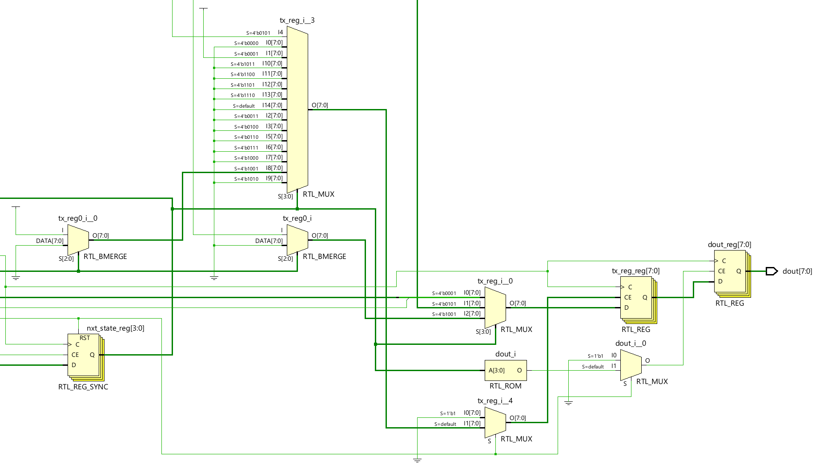

*Fig. 3.3. I2C Master’s Output side*

**3.1.7 Open-Drain Handling for SDA and SCL**

Since I²C buses operate on open-drain (wired-AND) signaling, the SDA and SCL lines are handled using conditional assignments: assign SDA = (sda == 0) ? 0 : 1'bz and similarly for SCL. This ensures the master only pulls the line low when necessary and otherwise leaves it floating ('z) so that other devices can drive it. Pull-up resistors (external or simulated with pullup) ensure the line returns to high when not driven.

**3.2 Slave_Module**

The i2c_slave module represents an I²C slave device that can receive or transmit data based on the master's command. It interacts with the SDA (bidirectional data line) and SCL (clock line), and it uses a reset signal to initialize its operation. The slave receives an address and data (din) from the system and responds with output data (dout) after receiving the correct read/write command from the I²C master. Internally, it uses a finite state machine (FSM), a data register, and control signals such as ACK, mode, and count to manage protocol operations.

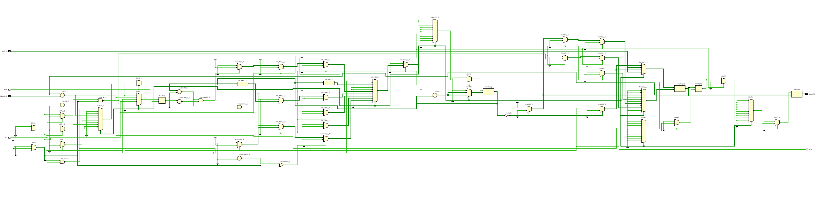

*Fig. 3.4. Overall Schematic of I2C Slave*

**3.2.1 Start Detection and State Machine Initialization**

The FSM starts in S0, where it waits for a valid START condition, which is indicated by SDA going low while SCL is high. This is detected using an additional signal sda_sense, which gates the sensitivity of the FSM to avoid unnecessary triggering. Upon detecting a START, the slave enters S1 and initializes counters and flags. The FSM uses 10 states (S0 to S9) to handle the full I²C transaction, transitioning between them based on SCL, SDA, and internal logic.

**3.2.2 Address Recognition**

In states S1 and S2, the slave shifts in 8 bits of data from the SDA line, storing them in tx_reg. These bits represent the 7-bit address and 1-bit R/W command sent by the master. In S3, the module compares the received address (top 7 bits of tx_reg) with its own. If matched, the slave acknowledges by pulling SDA low (sda = 0) and determines the operation mode (read or write) based on the LSB of tx_reg.

**3.2.3 Read/Write Data Phase**

In S4 and S5, the slave either prepares to send data (din) if in transmit mode, or prepares to receive data if in receive mode. The FSM uses count to keep track of bits transferred. In transmit mode, data bits are placed on the SDA line during SCL = 0. In receive mode, it keeps SDA high and reads bits into tx_reg on SCL = 1. The ACK flag tracks successful byte reception or transmission.

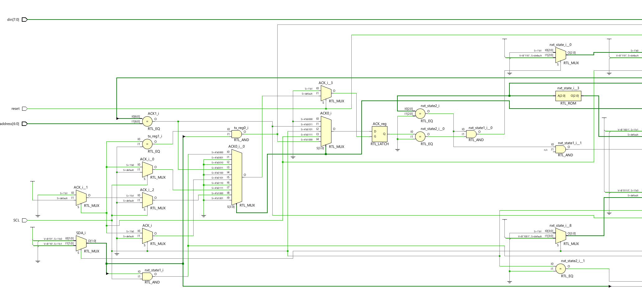

*Fig. 3.5. I2C Slave’s Input side*

**3.2.4 Data Acknowledgment and Latching**

In S6 and S7, the slave handles acknowledgment and processes the received byte. If in receive mode, once 8 bits are received, the slave pulls SDA low to ACK the reception. The received byte is latched to dout in state S8. If in transmit mode and the master ACKs the sent byte, the slave prepares the next data byte. If the master doesn't ACK, the slave resets or waits for a STOP.

**3.2.5 Stop Condition and Recovery**

The STOP condition is detected in state S9, where SDA goes high while SCL is high. If STOP is detected, the FSM resets to S0 and sets sda_sense = 1, preparing to detect the next START condition. If not, and SCL = 0, the FSM continues to the data transfer state (S6) depending on the mode. The FSM is also designed to handle repeated starts.

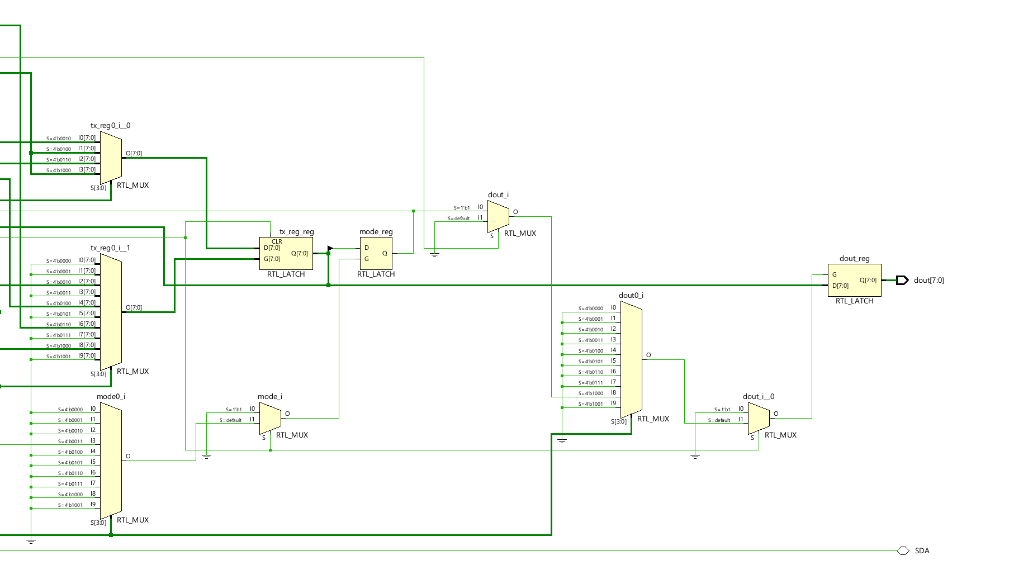

*Fig. 3.6. I2C Slave’s Output side*

**3.2.6 Open-Drain Output Handling**

Since the I²C protocol requires open-drain (wired-AND) signalling for the SDA line, the module uses a conditional assign: assign SDA = (sda == 1) ? 1'bz : 1'b0;. This ensures the slave only pulls the line low when needed (ACK, data transmit), and leaves it in high-impedance otherwise, allowing proper bus sharing.

**3.3 Verification Environment**

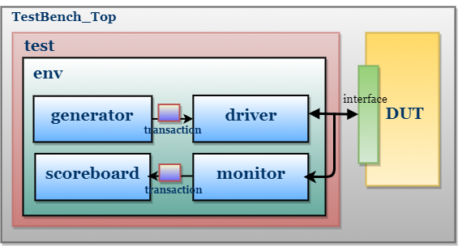

*Fig. 3.7. Testbench Architecture*

These are the main Components of System Verilog

**3.3.1 packet (transaction)**

The packet class in System Verilog models a data transaction for I²C verification. It contains randomized fields like address, data, and mode to simulate various inputs, while an error flag is used to detect mismatches during simulation. The display() task prints the packet contents, and the compare() task checks the received packet against an expected one, reporting any mismatch. This class plays a key role in testbenches by enabling structured stimulus generation and result validation, which is essential for functional verification.

**3.3.2 Generator**

The generator module plays a vital role in producing randomized I²C protocol stimuli by generating address, mode (read/write), and data signals, encapsulated within a packet class object. These signals are randomized using the randomize() method and then propagated to the master and slave drivers. The address signal defines the target I²C device, mode specifies whether the operation is a read (1) or write (0), and data carries the actual 8-bit payload. This randomized generation ensures diverse test coverage, allowing the verification environment to rigorously test different I²C communication sequences and uncover edge-case failures.

**3.3.3 Driver**

This SystemVerilog code defines two classes—master_driver and slave_driver—that model the behavior of I²C master and slave components in a UVM-like verification environment. Each driver interfaces with its corresponding virtual interface (master_interface or slave_interface) and communicates with a scoreboard through a mailbox. The master_driver class handles generating randomized transactions (read or write), toggling the start and stop signals appropriately, and sampling data at specific clock edges. It supports both masters transmit and receive operations. Similarly, the slave_driver class responds to master transactions based on the mode; in receiver mode, it samples data from the master, and in transmitter mode, it generates random data to send back. Both classes utilize clock-based synchronization to model protocol timing and ensure accurate data exchange during testbench simulation.

**3.3.4 Interface**

This module has the declaration of all the signals of master and slave. All the datatypes should be of logic datatype.

**3.3.5 Monitor**

The monitor component in the context of the I²C verification environment plays a passive yet critical role by observing signal activity on the bus without driving or altering any values. It captures transactions from the master and slave interfaces, extracting relevant data such as address, mode (read/write), and data bytes, and sends this information to the scoreboard for comparison. The monitor ensures protocol compliance and enables functional coverage collection by analyzing actual communication patterns, helping to detect mismatches or violations when compared to the expected behavior defined in the testbench.

**3.3.6 Scoreboard**

This System Verilog scoreboard class is used in the testbench to compare the data exchanged between the I²C master and slave during simulation. It uses two mailboxes (sdrv2sb and mdrv2sb) to receive data from the slave driver and master driver respectively. The start task runs for a given number of bytes, retrieves the transmitted and received values, and compares them. If the values match, a "PASS" message is displayed; otherwise, an error is counted and a "FAIL" message is shown. This helps in validating functional correctness of the data transfer. The class also includes commented-out code for an assertion to check correct start condition behavior, showing how assertions can be integrated to monitor protocol-level requirements.

**3.3.7 Testcase**

This System Verilog testcase program sets up and runs a test scenario for verifying an I²C communication system using the environment class. It begins by creating an instance of the environment with master and slave interfaces (mintf and sintf). The test sequence includes building the environment, applying a reset, and then initiating data transactions using the start() method with a specified number of bytes (5 in this case). The code structure utilizes fork...join to allow concurrent execution of the test stimulus. After the first transaction, the test mistakenly attempts to rebuild the environment mid-simulation (env.build()), which may cause simulation errors due to reinitialization. Following this, another reset is applied and a second transaction is run. The test ends after a delay using $finish. This testbench mimics a realistic verification flow for validating read and write operations over an I²C protocol.

**3.3.8 Assertion**

The assertions module defines a comprehensive set of System Verilog assertions to validate key I²C protocol rules and ensure signal correctness throughout communication. These assertions monitor events such as START and STOP conditions, signal stability, and acknowledgment behaviour. The module uses the property-assert constructs to catch violations and report meaningful error messages during simulation. Each property enforces a specific protocol requirement, helping ensure reliable bus behaviour and proper master-slave interactions.

Here are the assertions implemented:

* **sda_changes_when_scl_low**: Ensures SDA only changes when SCL is low (except for START/STOP).
* **start_condition**: Confirms that SDA falls when SCL is high during a START.
* **stop_condition**: Checks that SDA rises when SCL is high during a STOP.
* **bus_idle_after_reset**: Ensures the bus is idle (SCL and SDA high) after reset.
* **address_stable**: Verifies that the address remains stable after a START condition.
* **rd_wr_valid_after_start**: Ensures a valid read/write signal is present shortly after START.
* **data_stable_when_scl_high**: Makes sure din is stable when SCL is high.
* **dout_update_after_read**: Ensures dout gets updated properly after a read operation.
* **no_multiple_starts**: Prevents issuing multiple STARTs without a STOP in between.

**3.4 I2C Format**

**3.4.1 Start Condition**

The start condition marks the beginning of communication on the I²C bus. It is generated by the master by pulling the SDA line low while the SCL line remains high. This specific transition is recognized by all devices connected to the bus, signalling them to listen for a potential address match. Without a valid start condition, no device on the bus will respond.

**3.4.2 Address Phase**

After the start condition, the master sends a 7-bit slave address followed by an R/W bit, making it an 8-bit address frame. The R/W bit determines the direction of the data transfer:

* 0 indicates a write operation (master to slave)
* 1 indicates a read operation (slave to master)

All slaves receive this frame, but only the one whose address matches responds. Addressing is critical as it selects which slave the master will communicate with.

**3.4.3 Acknowledgment (ACK/NACK)**

Once a slave detects its address, it sends an ACK (acknowledge) bit to the master by pulling the SDA line low during the ninth clock pulse. If no device matches the address, the SDA line stays high, resulting in a NACK (not acknowledged). Similarly, after every 8 bits of data, the receiver (slave or master, depending on direction) sends either an ACK (for successful reception) or NACK (to indicate an error or end of transmission).

**3.4.4 Data Transfer**

Data transmission happens one byte at a time (8 bits per byte). The master provides the clock pulses on SCL, and data is transferred over the SDA line, most significant bit (MSB) first.

* In a write operation, the master sends data to the slave. The slave acknowledges each byte with an ACK.
* In a read operation, the slave sends data to the master. After each byte, the master sends an ACK if it wants more data or a NACK if it's done.

This handshake ensures data is exchanged reliably.

**3.4.5 Repeated Start Condition**

Sometimes, the master might want to communicate again without releasing the bus, for example, to switch from writing to reading. In such cases, the master issues a Repeated START condition instead of a STOP. This is identical in waveform to a regular start condition and allows uninterrupted communication on the bus.

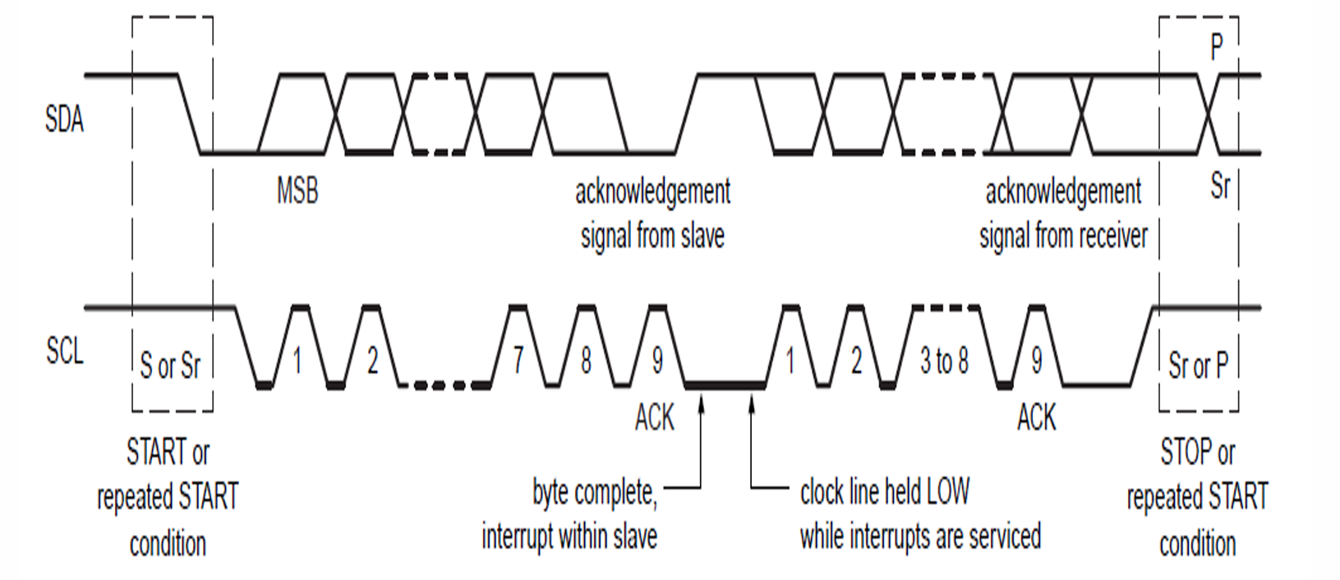

*Fig. 3.8 Format of I2C Protocol*

**3.4.6 Stop Condition**

Once all data has been exchanged, the master sends a STOP condition to end the communication. This is generated by releasing the SDA line from low to high while SCL is high. This transition informs all devices that the bus is now free, allowing other masters (if any) to start communication. In the case of a read operation, the master must first send a NACK after the final byte before issuing the stop.’

**3.4.7 Arbitration and Clock Stretching**

In multi-master systems:

* **Arbitration** ensures only one master controls the bus. If two masters try to communicate simultaneously, the one that sees a mismatch between the SDA value it sent and the one on the line (i.e., it wrote a ‘1’ but sees a ‘0’) backs off, allowing the other to continue.
* **Clock stretching** allows a slave to slow down communication by pulling SCL low. The master must wait until SCL is released before continuing. This is useful for slower devices that need more processing time.

**CHAPTER 4**

**SIMULATION RESULTS**

**4.1 EDA PLAYGROUND SIMULATION OUTPUT**

**4.1.1 Master’s Simulation Results**

In the *Fig.4.1,* we observe the I2C master's behavior during simulation. The SCL and SDA lines show standard I2C signaling, with SDA toggling relative to SCL for valid data transmission. The master initiates communication when start is asserted, and drives a valid 7-bit address (0x07, then 0x72) onto the bus. The mode signal determines the direction (read/write), with mode = 0 indicating read in this case. Data is sequentially transmitted over din and visible in the tx_reg, while the count tracks the number of bits sent. The master releases control after asserting the stop signal, indicating the end of transmission. The ack_r signal is asserted once the data is received correctly from the slave. This confirms correct master-side protocol behavior in the simulation.

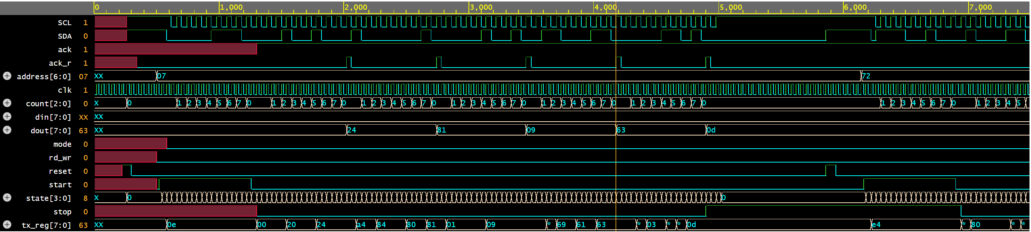

*Fig.4.1. Waveform showing the correct working of I2C Master*

**4.1.2 Slave’s Simulation Results**

In the *Fig.4.2,* We can see the slave correctly responds to the master's I2C transactions. The slave monitors the SCL and SDA lines and decodes the incoming address (0x07 and later 0x72). When a matching address is detected and mode = 0 (Read operation), the slave captures data on dout (0x24, 0x81, 0x09 etc.) as it's received over the bus. The count signal tracks bit positions, and data is assembled in tx_reg before being driven to the internal logic. Overall, the slave demonstrates proper data reception and protocol compliance throughout the transaction.

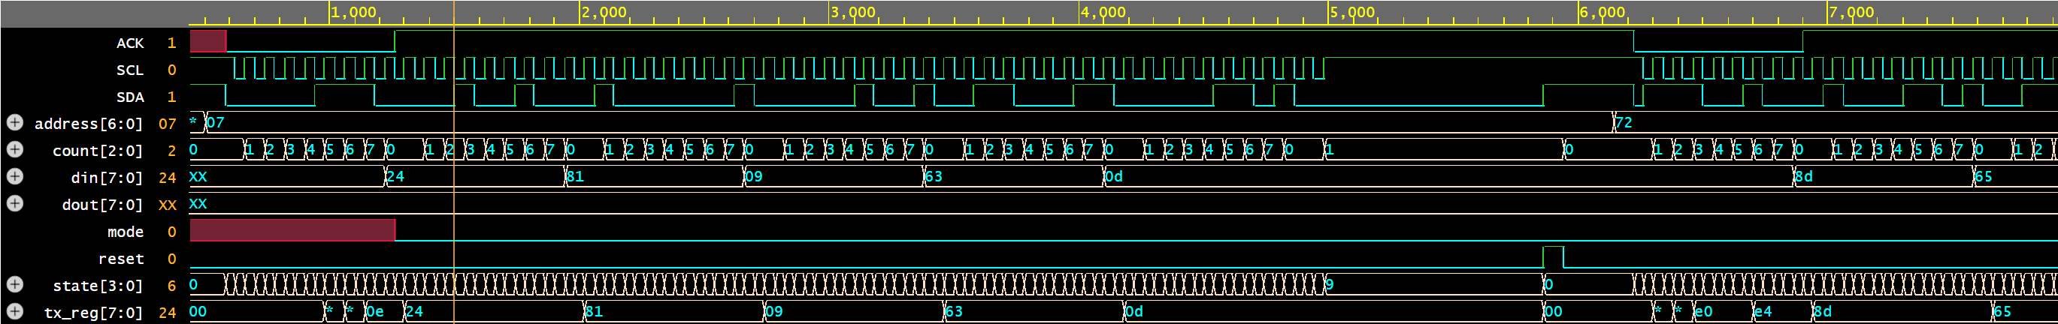

*Fig.4.2. Waveform showing the correct working of I2C Slave*

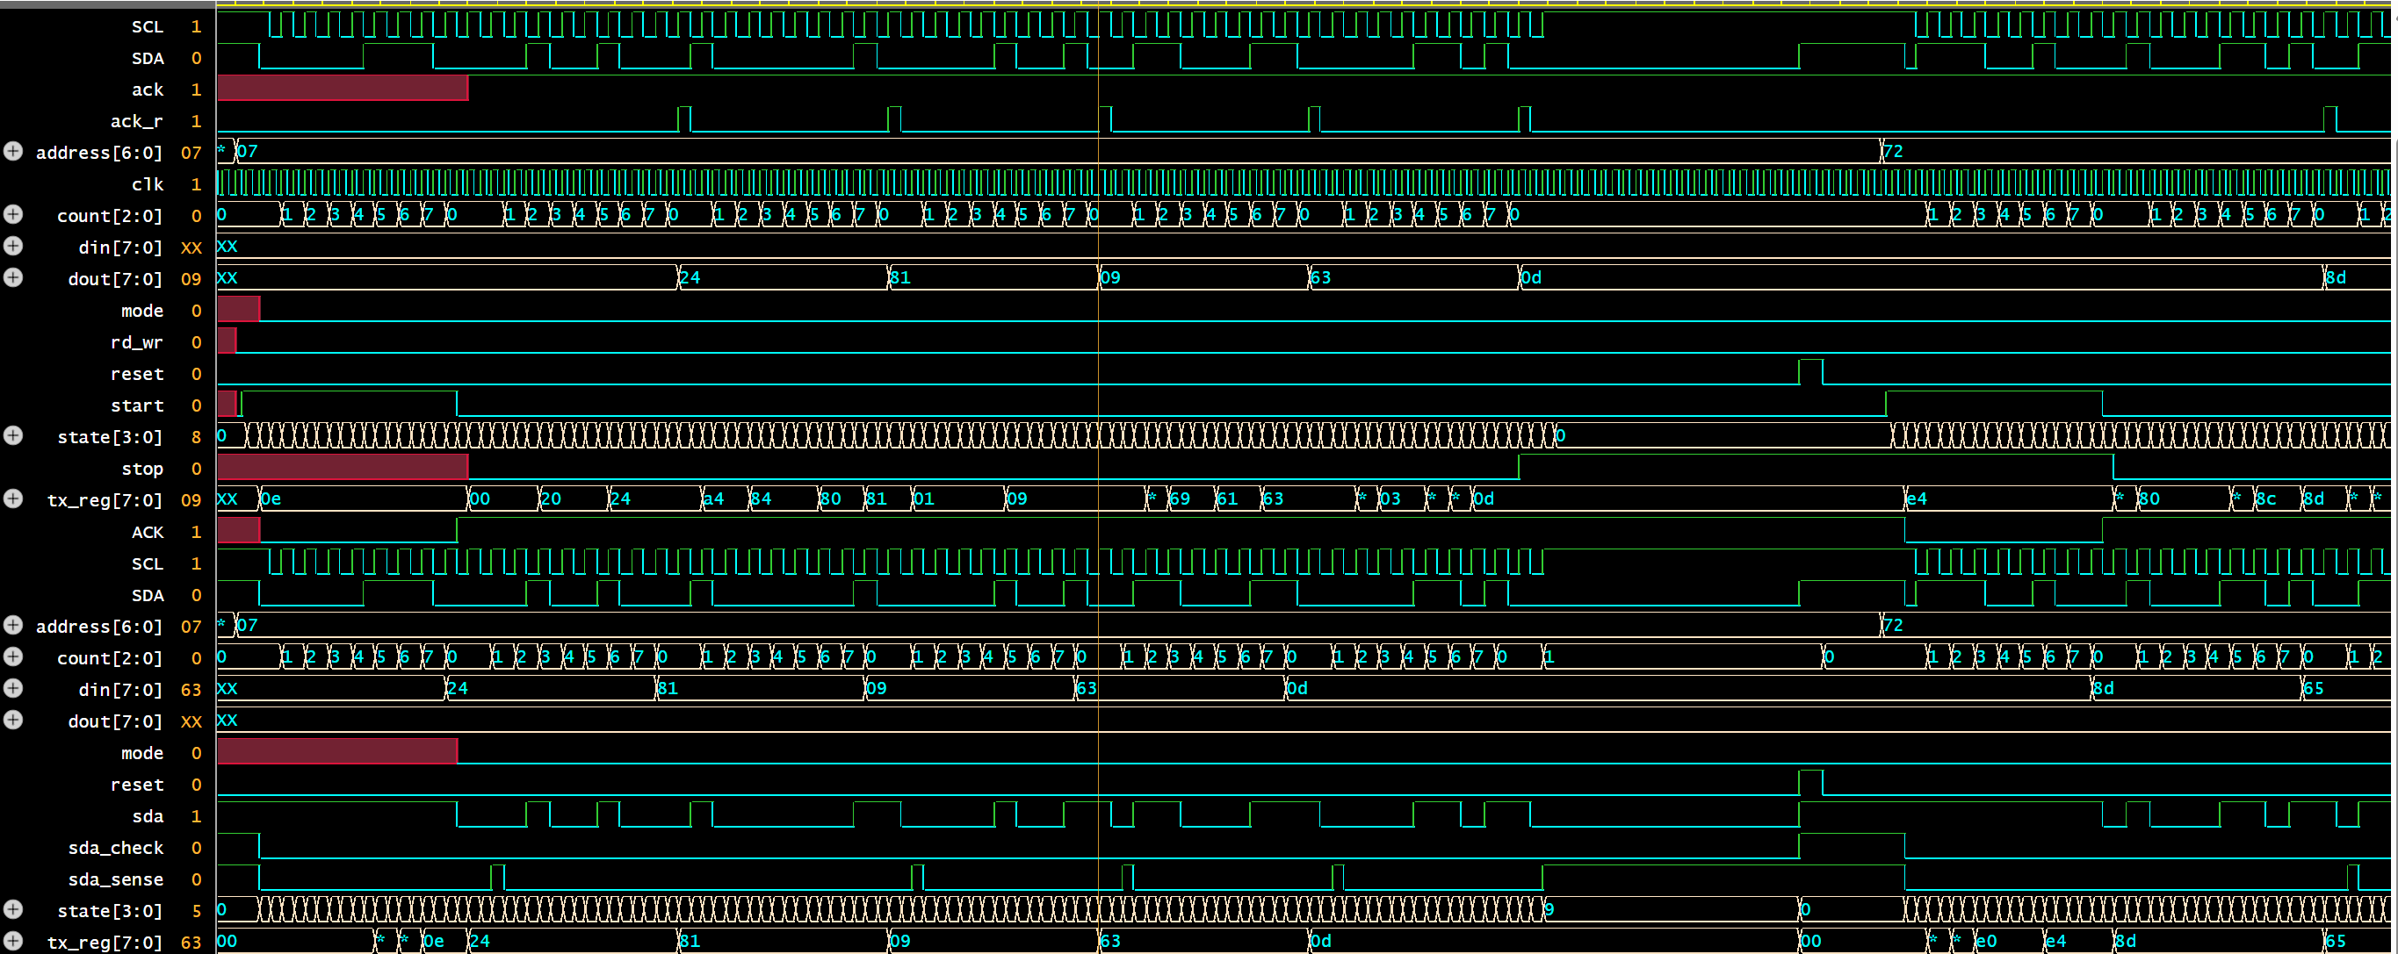

*Fig.4.3. Handshake between I2C Master and Slave*

**4.2 DATA COMPARISON SIMULATION OUTPUT**

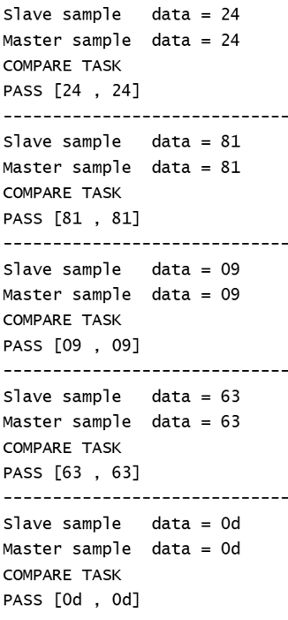The *Fig.4.4* displays the comparison results of data transmitted and received between the master and slave during I2C communication. Each block shows data sampled by the slave and later echoed or matched by the master, along with their respective timestamps. The compare task checks confirm that all data pairs match correctly (e.g., 0x24, 0x81, 0x09, 0x63, 0x0d), indicating proper data exchange. This verifies that the protocol-level data transfer between master and slave is functioning as intended.

*Fig.4.4. Data Comparison Simulation output*

**4.3 ASSERTION OUTPUT**

As mentioned in chapter 3.3.8, there are 9 assertions made for I2C Master and Slave. Assertion checks happen at every clock pulse and prints the display statements stating PASS or FAIL. The *Fig.4.5* shows the results of a System Verilog assertion used to validate the START condition in an I2C protocol. The assertion is checking for a falling edge on SDA while SCL is high, which is the correct definition of an I2C START condition: ((SCL === 1'b1) && $fell(SDA)). Initially, the assertion fails at times 540 ns and 580 ns, indicating that an incorrect START condition was detected—most likely due to a glitch or a protocol timing violation. However, by 620 ns, the condition is met correctly, and the assertion passes, confirming a valid START event was eventually observed. This pattern suggests a timing or signal control issue during the early part of the communication setup. Assertion will hit only once when the START, SCL and SDA satisfies the condition as mentioned in the RTL code. The time when Assertion passes can be verified with *Fig.4.1* also*.*

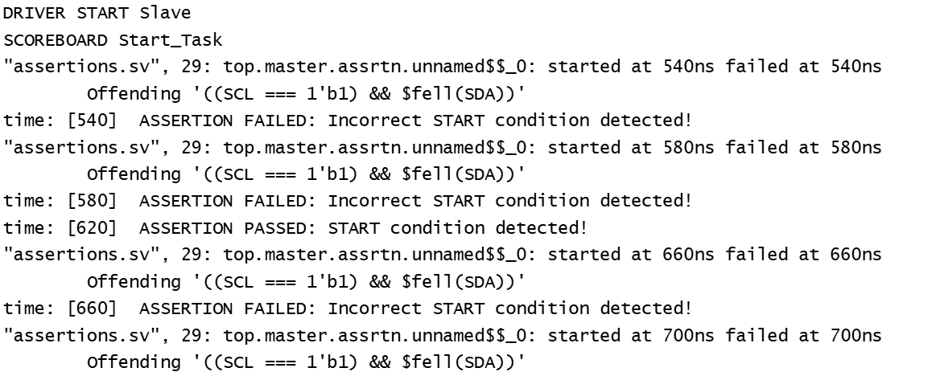

*Fig.4.5. Assertion START condition result*

The *Fig.4.6* shows the assertion simulation output for STOP condition. The output in the figure displays the simulation results of a STOP condition assertion in an I2C protocol. The assertion checks for a valid STOP condition, defined as a rising edge on SDA while SCL is high—expressed as ((SCL == 1'b1) && $rose(SDA)). The logs show that multiple STOP condition checks failed at different time points (e.g., 5820ns, 5860ns, 5940ns, etc.), indicating that the STOP condition was either mistimed or improperly formed during those intervals. However, there is one successful assertion at 5900ns, confirming that a correct STOP condition was detected at that specific moment. This mixed result highlights instability or timing issues in STOP condition handling, suggesting a need to verify the design's control over SCL and SDA during transaction termination.

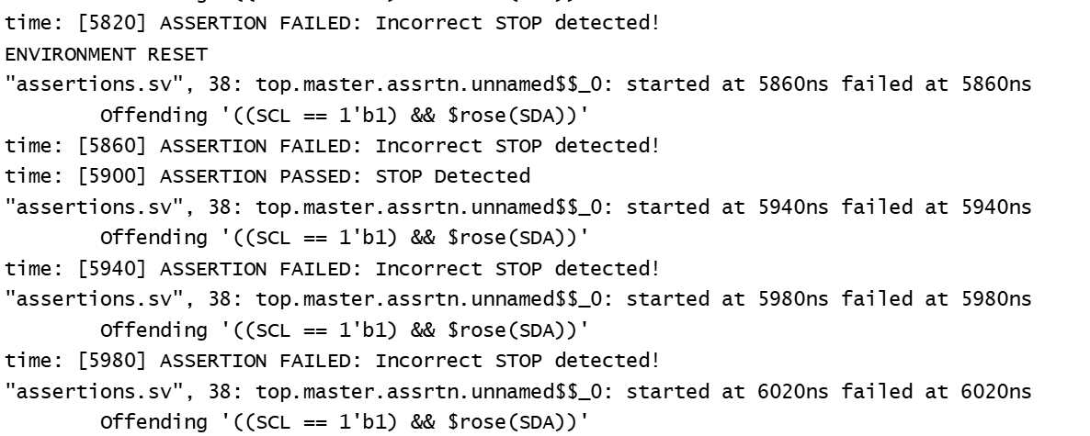

*Fig.4.6. Assertion STOP condition result*

**4.4 PERL SCRIPT OUTPUT**

The displayed log in *Fig.4.7* captures a successful I2C transaction, detailing the sequence of events including START condition, address transmission (0x07), data transfer (0x14), and STOP condition, followed by a successful data comparison (PASS [24, 24]). This structured log format is being used as input to a Perl script developed for automation of verification. The script reads the timestamps, address, and data values, and performs comparisons between master and slave values to detect mismatches, streamlining the validation process and enhancing debugging efficiency.

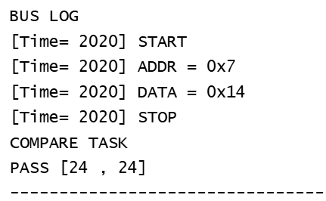

*Fig.4.7 Bus Log for one data and*

*address in simulation time*

These data are gathered and used as the input to Perl script created as shown below in the *Fig.4.8.* After running the script in the terminal, it gives the results which includes New Transaction made every time, address, mode, data and the total number of transactions made.

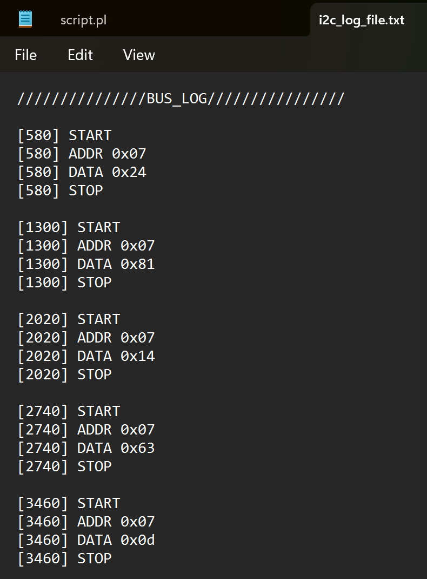 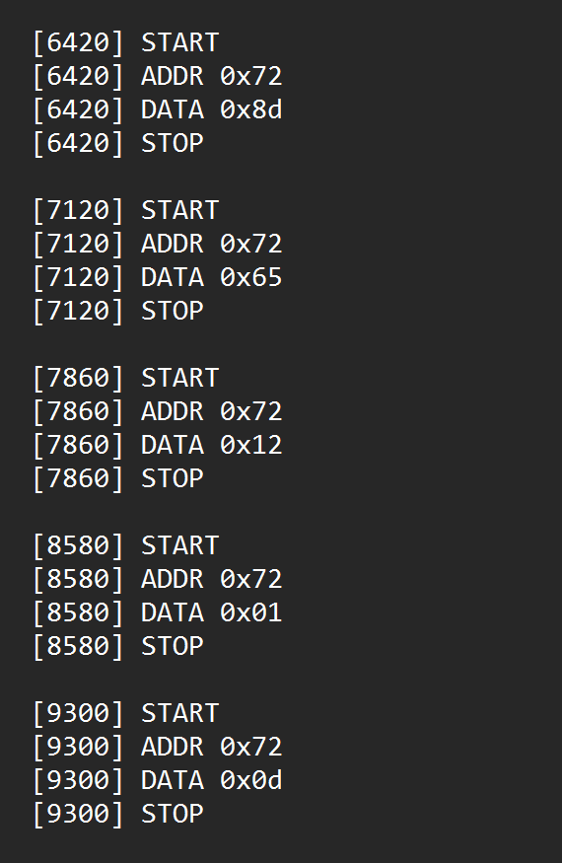

*Fig.4.8 I2C Bus log*

The displayed terminal output is the result of running a Perl script (script.pl) designed to parse and organize I2C transaction logs. Each transaction from the log is neatly extracted and displayed with essential details such as the transaction number, slave address, communication mode (READ), transmitted data, and the STOP condition. This structured presentation allows for easy inspection and debugging of I2C operations, especially in verifying whether the data received from the master matches the expected protocol behavior. The script effectively groups multiple log entries into meaningful transactions, which is particularly useful during post-simulation analysis in verification environments. This output demonstrates that the Perl script successfully interprets the raw bus data and outputs it in a human-readable, organized format for validation or further automated checks as me.

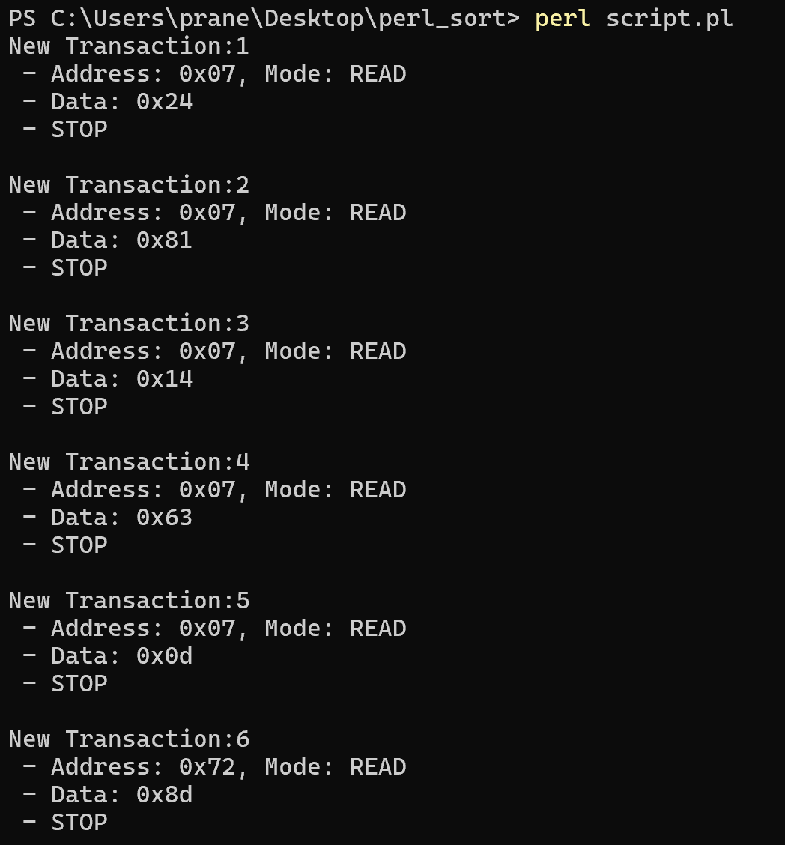 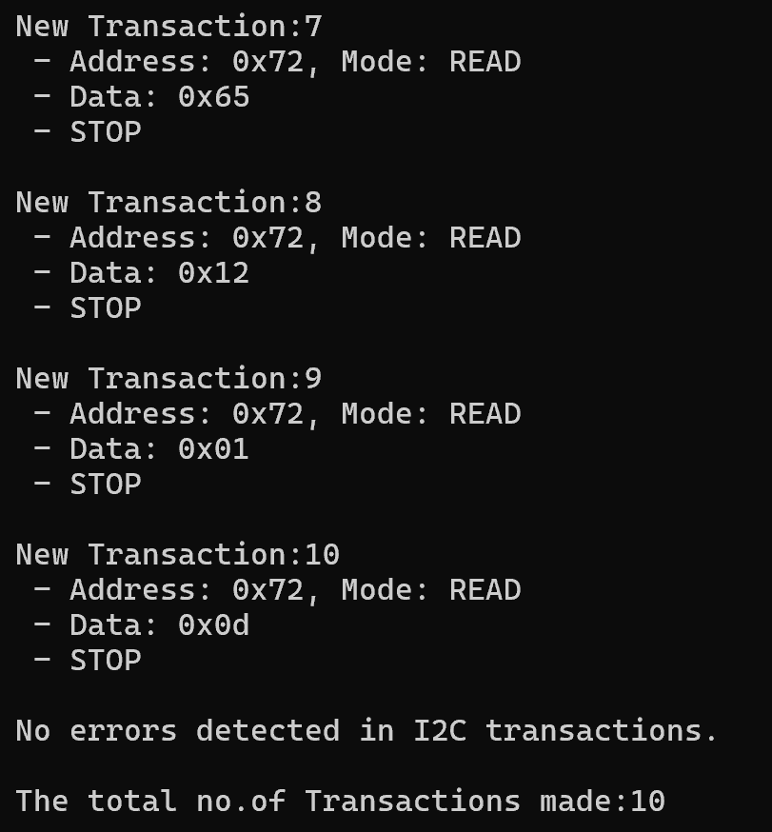

*Fig.4.9 Perl Script Output*

**CHAPTER 5**

**CODE COVERAGE**

**5.1 Work Done in Code Coverage**

Code Coverage work was assigned as a task to improve the code coverage of apb_arbiter, apb_sync, paddr_decoder, apb_mux, ctrl_fsm_cm modules. Code coverage is an essential aspect of functional verification in digital design, particularly in complex VLSI projects. It refers to the process of measuring how thoroughly the testbench stimulates the design under test (DUT). The primary goal of code coverage is to ensure that all parts of the design code have been executed and validated by the testbench. Without adequate code coverage, there is a high risk of shipping a design that may behave unpredictably in real-world scenarios because certain logic paths or edge cases were never exercised during simulation.

In industry-grade verification environments, code coverage is used to complement functional coverage. While functional coverage measures whether specific features or scenarios defined by the specification are tested, code coverage focuses on the actual implementation — the lines, conditions, and constructs written in the RTL (usually in Verilog or VHDL). Code coverage analysis allows verification engineers to identify untested areas in the code, improve the quality of testbenches, and ultimately increase confidence in the correctness of the design before tape-out.

**5.1.1 Line (Statement) Coverage**

This is the most basic form of code coverage. It tracks whether each line of executable code in the RTL was executed at least once during simulation. If certain lines are never executed, it may indicate dead code, unreachable logic, or incomplete test scenarios. Line coverage is a good starting point, but it is not sufficient on its own to guarantee full functional correctness.

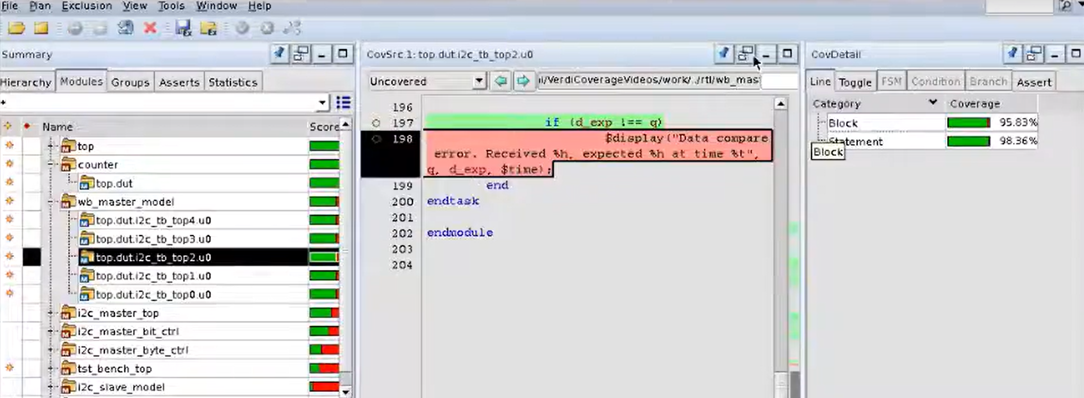

*Fig.5.1 Line Coverage in Verdi Tool*

**5.1.2 Toggle Coverage**

Toggle coverage monitors whether individual bits in signals have toggled from 0 → 1 and 1 → 0 during simulation. This is particularly useful for verifying data paths, buses, and registers. For instance, a data bus might always carry zero in the testbench due to an oversight, and toggle coverage would flag this by showing that the bits never changed. Ensuring toggle coverage helps validate that the dynamic behavior of signals is exercised.

**5.1.3 Condition Coverage**

Condition coverage (also known as sub-expression coverage) ensures that all Boolean conditions in a statement (such as if (a && b)) evaluate to both true and false. It breaks down compound conditions and checks each individual Boolean operand. For example, if a && b is always true because b is never false, the condition coverage will report incomplete coverage. This helps detect hidden logic bugs and incomplete test scenarios.

**5.1.4 Branch Coverage**

Branch coverage measures whether all branches in the control flow have been exercised — including both the if and else branches, all case items, and loops. This ensures that each decision point in the code has had all possible outcomes tested. Incomplete branch coverage can result in unverified logic paths that could lead to unexpected behaviours.

**5.1.5 FSM (Finite State Machine) Coverage**

FSM coverage applies to designs that use state machines, which are prevalent in protocol controllers, bus arbiters, and other control-intensive logic. This metric tracks whether all the states and transitions between states have occurred during simulation. Missing state coverage might mean that certain events or edge cases are not being generated in the testbench. This is critical because bugs often hide in rarely used transitions or error states.

**5.1.6 Expression Coverage**

Expression coverage examines more complex expressions involving multiple variables and operators. It checks all possible combinations of operand values to determine whether the expression has been fully evaluated in every way. For example, in a ternary operator like (sel) ? a : b, expression coverage checks both cases: when sel is true and when it is false. This ensures a more exhaustive validation than condition coverage alone.

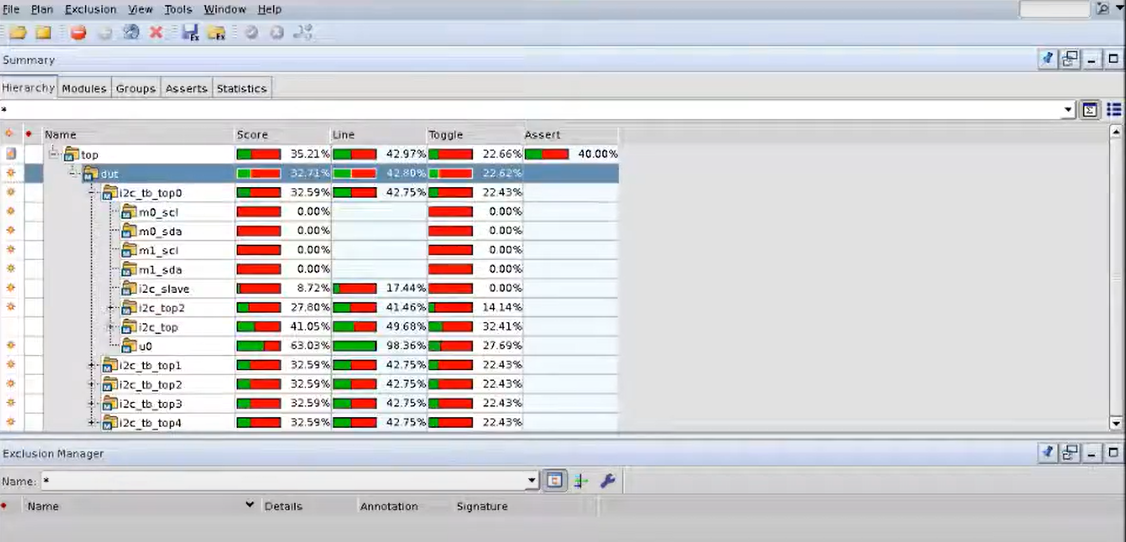

*Fig.5.2 Code Coverage in Verdi tool*

**5.2 Code coverage flow**

In Synopsys Verdi, functional coverage verification entails examining and verifying the testbench stimuli's completeness as well as making sure they exercise the intended functionality of the design under test (DUT). Metrics for measuring functional coverage keep track of the components of the design that have been evaluated extensively through simulation.

**5.2.1 Coverage Database Generation:**

• During simulation, Verdi collects coverage data based on the defined coverage points and stores it in a coverage database file (.ucdb). Before running simulations, you need to define functional coverage points in your SystemVerilog or VHDL testbench code using coverage directives such as covergroup and coverpoint.

**5.2.2 Simulation Setup:**

• Use Synopsys VCS or another supported simulator to compile and elaborate your design and testbench.

• Enable coverage collection in the simulation by specifying appropriate command line options or settings in your simulation scripts.

**5.2.3 Simulation and Coverage Collection:**

• Run your simulation with the enabled coverage collection.

• Verdi collects coverage data during simulation execution and updates the coverage database file (.ucdb) with the coverage results.

**5.2.4 Integration with Verification Planning Tools:**

• Verdi can be integrated with verification planning tools such as Synopsys VC LP (Verification Compiler Test) to link coverage goals defined in the verification plan with actual coverage results obtained during simulation.

• This integration enables you to track coverage progress against verification plan goals and ensure that verification objectives are met.

Verdi Code Coverage is a powerful feature of the Synopsys Verdi tool suite, designed to assist verification engineers in analyzing and optimizing testbench effectiveness by tracking how thoroughly the RTL code has been exercised during simulation. Verdi is widely used in the semiconductor industry not only for waveform debugging and tracing signals but also for in-depth functional and code coverage analysis. When integrated with simulators like VCS, Verdi provides a comprehensive and interactive GUI for visualizing coverage metrics.

Additionally, Verdi supports merging coverage data from multiple simulation runs, which is essential when dealing with randomized testing or large designs. Engineers can also set coverage goals, filter out irrelevant sections (using exclude directives), and generate detailed reports to track verification progress. Overall, Verdi’s code coverage features are essential in ensuring high-quality, thoroughly tested digital designs before tape-out.

**CHAPTER 6**

**SUMMARY AND CONCLUSION**

**6.1 Summary**

The Inter-Integrated Circuit (I²C) protocol, introduced by Philips (now NXP Semiconductors), is a popular two-wire, bidirectional communication protocol widely used for low-speed, short-distance data exchange between integrated circuits, particularly in embedded systems. Its defining features include simplicity, scalability, and support for multi-master and multi-slave communication over just two lines: SDA (Serial Data) and SCL (Serial Clock).

I²C operates in master-slave architecture, where the master initiates communication and controls the clock, while the slave responds based on the address sent by the master. Data is transferred in 8-bit packets, accompanied by acknowledgment (ACK) bits, and the communication is synchronized using clock edges. It supports multiple speed modes — Standard (100 kbps), Fast (400 kbps), Fast Plus (1 Mbps), and High-Speed Mode (3.4 Mbps).

From a hardware implementation perspective, I²C is relatively simple, requiring only two pull-up resistors and open-drain or open-collector outputs. It has become an industry standard for interfacing peripheral devices like EEPROMs, RTCs, ADC/DACs, sensors, and display drivers. Its bus arbitration and synchronization mechanisms make it suitable for complex systems with multiple masters.

In recent VLSI and SoC design research, I²C is being extensively modeled, simulated, and verified using Verilog, VHDL, UVM, and SystemVerilog testbenches. Verification environments often include drivers, monitors, and scoreboards, with synchronization techniques using clocks and assertions. Simulation outputs and logs are used to drive further analysis and automation through scripts, including Perl and Python.

Moreover, design coverage and code coverage analysis using tools like Synopsys Verdi are vital in verifying that all paths, conditions, and state transitions in I²C RTL designs are exercised. Assertions are employed to ensure protocol compliance, such as start/stop detection, address validity, data integrity, and timing correctness.

**6.2 Conclusion:**

The I²C protocol remains a cornerstone in digital communication for embedded and semiconductor systems due to its ease of use, low pin count, and versatility. Whether in consumer electronics, industrial applications, or automotive systems, I²C enables reliable and structured data exchange.

Its adaptability across diverse clock domains and ability to manage multiple devices make it ideal for System-on-Chip (SoC) integration. Continued advancements in simulation, verification methodologies (like UVM), and design automation have further strengthened I²C's relevance in modern ASIC and FPGA development.

I²C is more than just a protocol — it is a fundamental enabler of seamless communication within electronic systems, backed by strong industry support and rich educational and research material. As systems continue to grow in complexity, protocols like I²C will remain crucial in ensuring modularity, reliability, and scalability in digital designs.

In conclusion, the I²C protocol implementation and verification performed in this project reflect a structured and disciplined approach typical of modern VLSI design environments. The simulation flow was built using SystemVerilog and included master and slave drivers, interfaces, environment instantiation, and the use of key verification constructs such as mailboxes and assertions. This allowed for the functional simulation of write and read operations across multiple clock cycles, ensuring the protocol behaved according to specification. Assertions, such as those checking for START and STOP conditions, added robustness by automatically flagging any violations, while log files were parsed using Perl scripts to automate result extraction and analysis.

**6.3 Future Work**

Based on the code and simulation outputs discussed above, it is evident that the I²C protocol was implemented and verified using SystemVerilog constructs, including drivers, interfaces, and assertions to validate protocol functionality such as START, STOP, data transfer, and acknowledgement handling. This detailed verification setup, often part of a VLSI design verification flow, showcases how the protocol is mimicked through master and slave modules with appropriate synchronization on the clock and control lines. The implementation leverages functional coverage and assertion-based verification to ensure correctness. In the context of VLSI, where reliability and correctness are paramount, such verification environments are vital for validating the RTL at an early stage. Tools like Synopsys Verdi play a crucial role here, helping engineers debug waveform issues, monitor assertions, and analyze code coverage. The Perl scripting integration for log parsing further supports automation in the verification process, extracting useful metrics and validation points. As VLSI designs grow complex, this level of detailed simulation and verification will form the foundation for scalable and reusable IP blocks, ensuring protocol compliance and robustness in larger SoC architectures.

**REFERENCES**

[1] A. Chaithanya and A. Sainath, "Design of High-Speed I²C Interface Protocol Design and Its Verification Using SystemVerilog," *International Journal of Engineering Science and Research*, vol. 7, no. 5, pp. 647–654, May 2017.

[2] R. C. Radha and R. A. Kumar, "Design and Implementation of I²C Communication Protocol on FPGA for EEPROM," *International Journal of Scientific and Engineering Research*, vol. 9, no. 6, pp. 1609–1612, Jun. 2018.

[3] S. S. Raut and A. S. Patil, "Design and Implementation of I²C Protocol," *JournalNX – A Multidisciplinary Peer Reviewed Journal*, vol. 7, no. 5, pp. 46–50, May 2021.

[4] D. Thirumurugan and P. Harikrishna, "VLSI Implementation of SPI and I²C Communication Protocols," *International Journal of Advanced Research, Ideas and Innovations in Technology*, vol. 5, no. 4, pp. 403–406, Jul.–Aug. 2019.

[5] F. Hadinata, S. Yuwono, and F. Indrianto, "Design and Implementation of I²C Bus Protocol on Master and Slave Using FPGA," *Makara Journal of Technology*, vol. 26, no. 1, pp. 30–38, Apr. 2022.

[6] A. Tripathi, R. Jha and S. Prakash, "A Comparative Analysis of Communication Protocols in VLSI Design," *International Journal of Research Publication and Reviews*, vol. 5, no. 7, pp. 244–250, Jul. 2024.

[7] S. Kiruba and B. Bhavadharini, "Interfacing of Sensors with FPGA Board Using I²C Protocol," *IOSR Journal of Engineering*, Special Issue - ACCET’21, vol. 11, no. 2, pp. 16–21, Feb. 2021.

[8] B. Dineshkumar and R. Vignesh, "Design and Implementation of I²C Communication Protocol Using Verilog HDL," *International Journal of Scientific and Engineering Research*, vol. 11, no. 3, pp. 620–625, Mar. 2020.

[9] Synopsys Datasheets.